Predictive Model Plan – Credit Card Delinquency Prediction

Model Logic
We aim to predict whether a customer will become delinquent or non-delinquent based on their financial and demographic features.
Input Features (X)
The model uses variables such as:
- Age
- Income
- Credit Score
- Loan Balance
- Employment Status
- Card Type
- Customer Segment
These features represent a customer’s financial behavior and profile
Target Variable (y)
- Delinquent_Account
  - 1 → Delinquent
  - 0 → Non-Delinquent
⚙️ Model Workflow
- Data Preprocessing
  - Missing value imputation
  - Encoding categorical variables
  - Feature selection
- Train-Test Split
  - Data split into training and testing sets (e.g., 80:20)
- Model Training
  - Logistic Regression
  - Decision Tree
  - Random Forest (final model)
- Prediction
  - Model predicts probability of delinquency
- Evaluation
  - Accuracy
  - Precision, Recall, F1-score
  - Confusion Matrix
Final Model Choice
- Random Forest selected as best model
- Accuracy achieved: ~86%
- Handles non-linear relationships and feature interactions effectively
- 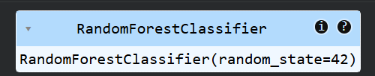
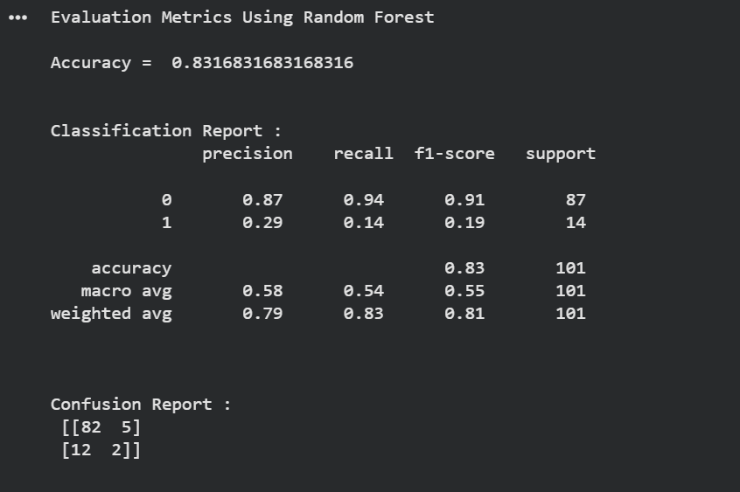

Justification for Model Choice
We evaluated multiple machine learning models to identify the best approach for predicting customer delinquency.

⚙️ Models Compared
- Logistic Regression
- Decision Tree Classifier
- Random Forest Classifier

📊 Performance Comparison
- Logistic Regression → Low performance (~47% accuracy) due to inability to capture complex, non-linear relationships.
- Decision Tree → Improved performance (~83% accuracy) but prone to overfitting.
- Random Forest → Best performance (~86% accuracy) with better generalization and stability.

🧠 Why Random Forest was selected
- Handles non-linear relationships effectively
- Reduces overfitting by combining multiple decision trees
- Provides higher accuracy and better stability compared to single models
- Works well with mixed data types (numeric + categorical features)
- More robust for financial risk prediction tasks

📌 Final Decision
Random Forest Classifier was chosen as the final model due to its highest accuracy and superior ability to generalize on unseen data, making it most suitable for predicting customer delinquency risk.

3. Evaluation Strategy
To assess model performance for predicting customer delinquency, multiple evaluation metrics and techniques were used to ensure reliability and fairness of results.

⚙️ Train-Test Split
- Dataset was split into:
  - Training set (80%) → model learning
  - Testing set (20%) → model evaluation
- Ensures model is tested on unseen data to avoid overfitting.

📊 Evaluation Metrics Used
1. Accuracy
- Measures overall correctness of predictions
- Useful for general performance comparison between models

2. Confusion Matrix
- Breaks predictions into:
  - True Positives (TP)
  - True Negatives (TN)
  - False Positives (FP)
  - False Negatives (FN)
- Helps understand types of prediction errors

3. Precision
- Measures how many predicted delinquents were actually delinquent
- Important to reduce false alarms

4. Recall
- Measures how many actual delinquents were correctly identified
- Critical for risk detection in banking

5. F1-Score
- Balance between Precision and Recall
- Used when class distribution is imbalanced

6. ROC-AUC (optional but strong)
- Measures model’s ability to separate classes
- Higher value → better classification performance

📌 Final Evaluation Approach
- Models compared using Accuracy + F1-score
- Random Forest selected based on highest overall performance and generalization ability

